DATA 260 Homework 3 Report
Sreeram Achutuni
SJSU ID: 019151808

Section 0: Config values
SID4 | 1808
PORT_BASE | 8008
PREFIX | s1808
SEED | 1808
VERIFY_SEED | 261808
DOMAIN_ID | 0, Campus course catalogue and enrolment
Hardware | Intel Core i7-11390H, 16GB RAM, integrated Iris Xe graphics (no dedicated GPU)
Local model | sentence-transformers/all-MiniLM-L6-v2 (embedding model, via HuggingFace, used for Part 2 retrieval). Part 1 (auth) does not call any model, it is just FastAPI + sessions.
Repo | https://github.com/sriram2930/Data260-1808
Commit tagged as hw3 | to be filled in once everything below is final and pushed

Part 1: FastAPI Authentication
This part adds a login/session/logout system on top of the HW2 course catalogue app, for the same Campus Course Catalogue and Enrolment domain. It uses Starlette's SessionMiddleware for sessions, a router file (auth.py) separate from the main app for the auth routes, and Bootstrap for styling.
Demo credentials are hardcoded (advisor / course123), there is no real user database here, the assignment only asks for a simple auth system.

Home page, not logged in
Shows a welcome message and a Log in link in the navbar.
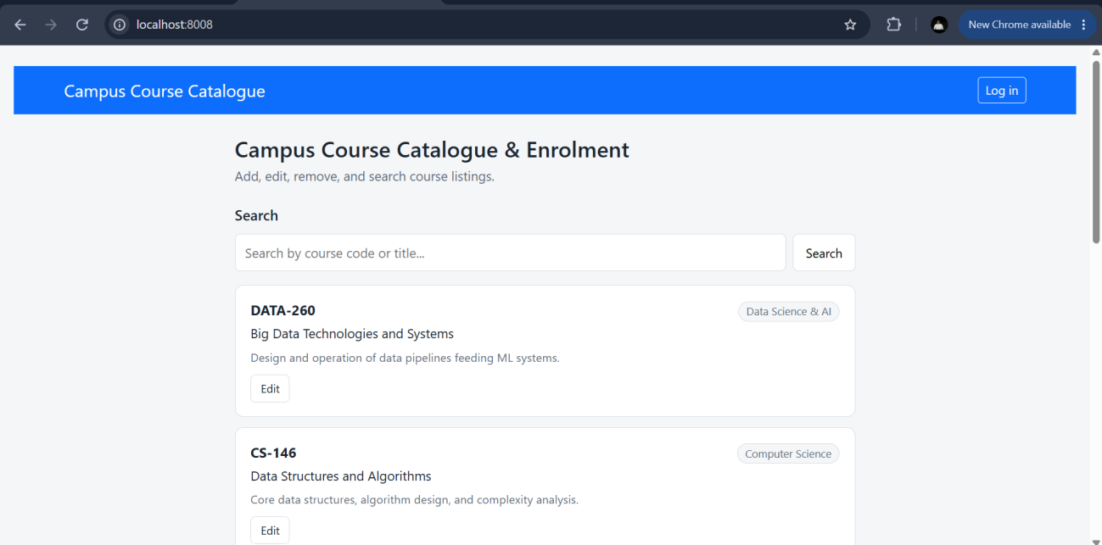

Login page
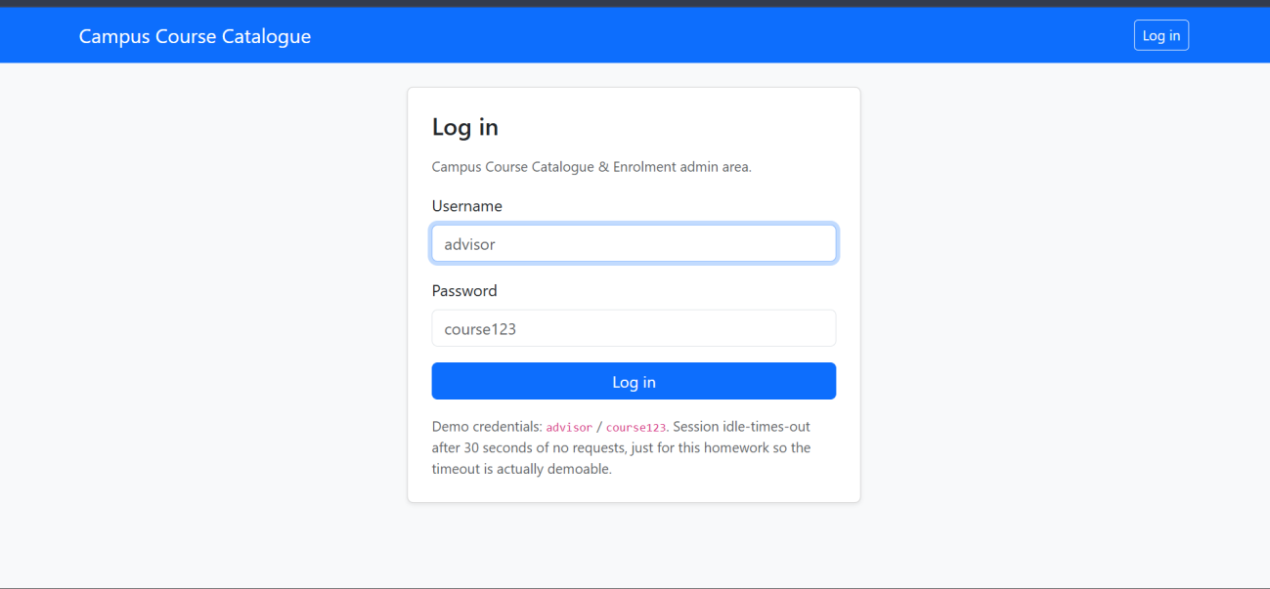

Login with wrong credentials
Entering a wrong password shows a Bootstrap alert instead of silently failing or crashing.
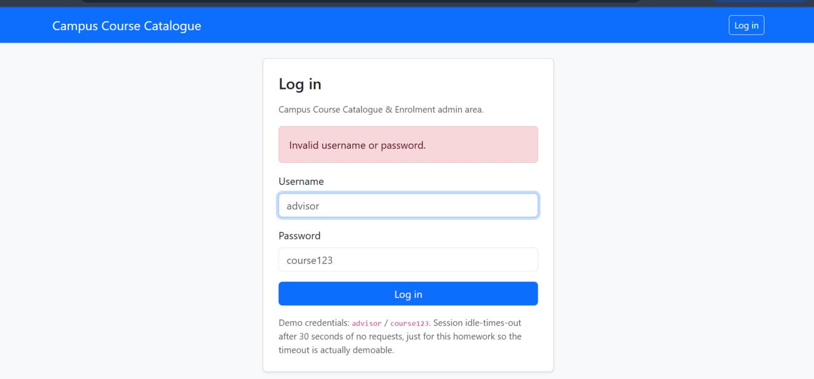

Dashboard page
Shows a welcome message with the logged in user's name plus a log out link. This route is protected, it checks the session before rendering anything.
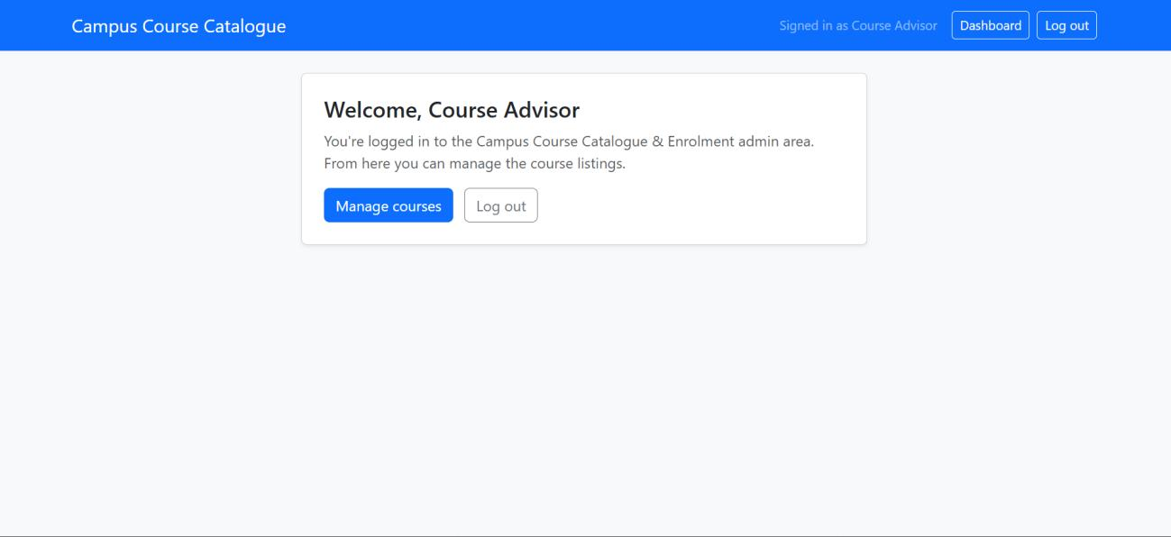

Home page, logged in
Same route as before, but now the navbar shows who is signed in plus Dashboard and Log out links instead of a Log in link.
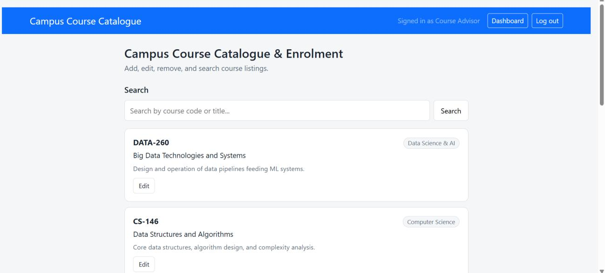

Dashboard blocked without a valid session
Going straight to /dashboard without a valid session redirects to /login with an alert explaining why.
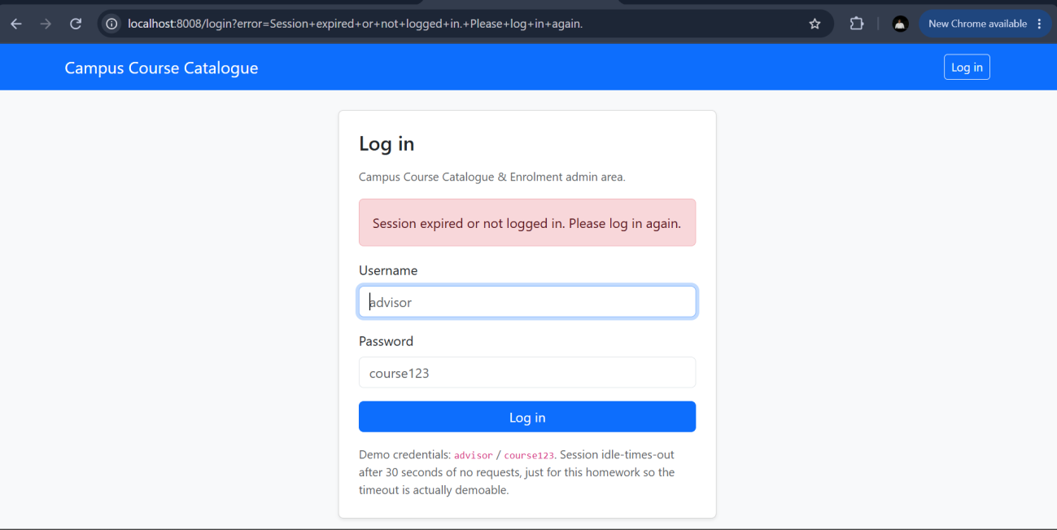

templates directory
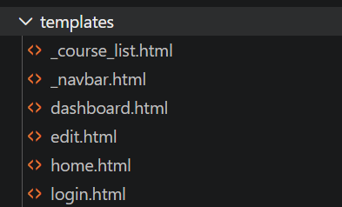

Session management
Sessions use Starlette's SessionMiddleware with a signed cookie. The cookie is set with httponly, secure, and samesite all on, which I confirmed by reading the raw Set-Cookie header rather than just assuming the middleware config did what I expected. I did not end up with a screenshot of that header in this report though, that check was done directly in the terminal earlier while building this and I forgot to grab dev tools output at the time. The actual header, from testing, looked like this:
s1808_session=...; path=/; Max-Age=1209600; httponly; samesite=lax; secure
For idle timeout, the cookie's own Max-Age is a fixed expiry counted from login time, it does not reset on activity, so it is not actually an idle timeout by itself. I added my own check on top: every request records a last_seen timestamp in the session, and if more than 30 seconds pass between requests, the session gets cleared and the user is treated as logged out. 30 seconds is short on purpose so this is actually demoable instead of having to wait a real session length.
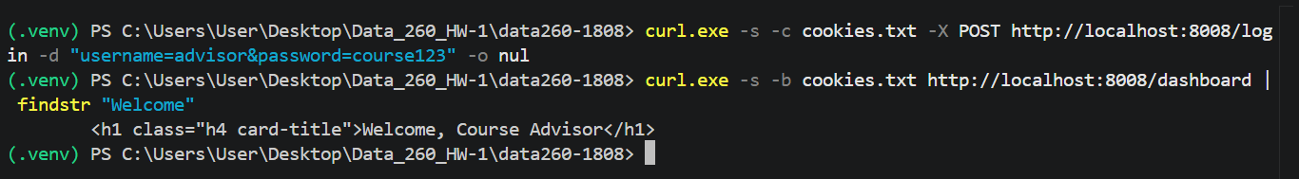
Login followed immediately by a dashboard request with the same cookie, showing the welcome message.
This screenshot only shows the immediate-after-login half working. I meant to also capture the same cookie reused after waiting past the 30 second timeout (which should then redirect to login instead of showing the dashboard), but I do not have that second screenshot in this report. The earlier browser screenshot above (URL bar showing /login?error=Session+expired...) is from testing this same behavior, but since that specific screenshot was taken by just visiting /dashboard cold rather than a timed wait-then-retry, it does not by itself prove the timeout specifically as opposed to simply not being logged in at all. The logic for both cases is the same code path either way (get_current_user returns None), I just do not have a clean screenshot isolating the timed-out case specifically.

auth.py
Full router file, session helper, and all four routes.
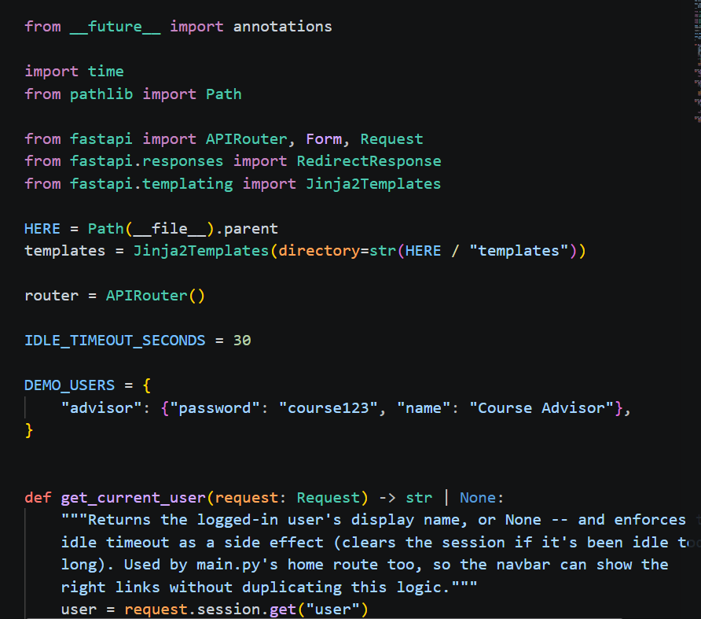
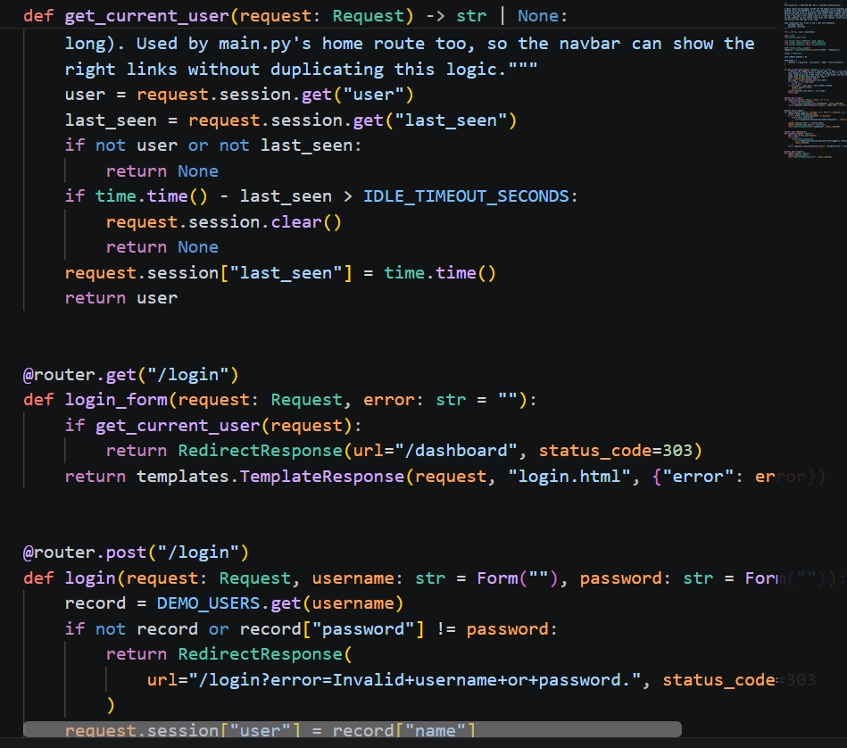
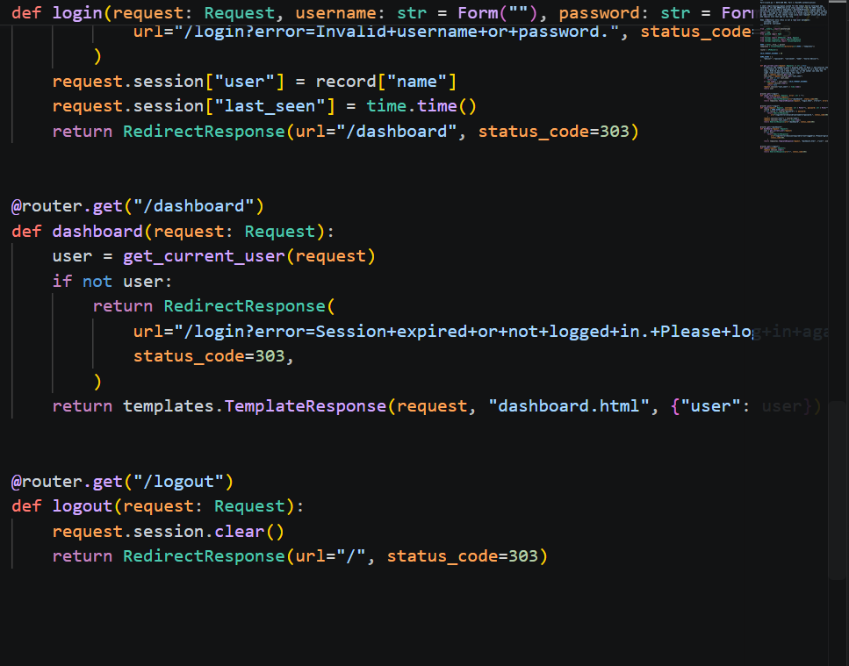

Part 2: Compare Three LlamaIndex Chunking Techniques
This part builds three separate in-memory vector indexes over the same local domain corpus, one per chunking technique (token, semantic, sentence window), and compares retrieval quality across all three using a shared retrieval-only function.

Corpus
32 real, public SJSU pages (registrar pages, admissions pages, and department/college student success center FAQ pages), fetched and cleaned to plain text, 208.4KB total, over the 200KB minimum. Sources and access dates are in SOURCES.md, and CORPUS_MANIFEST.json records each local filename, byte size, and SHA-256 hash.
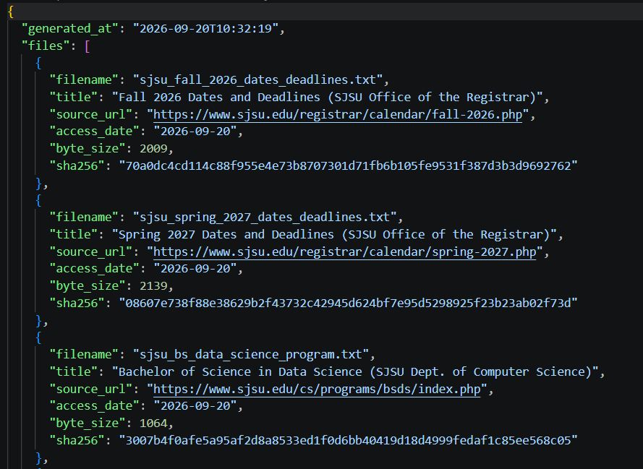
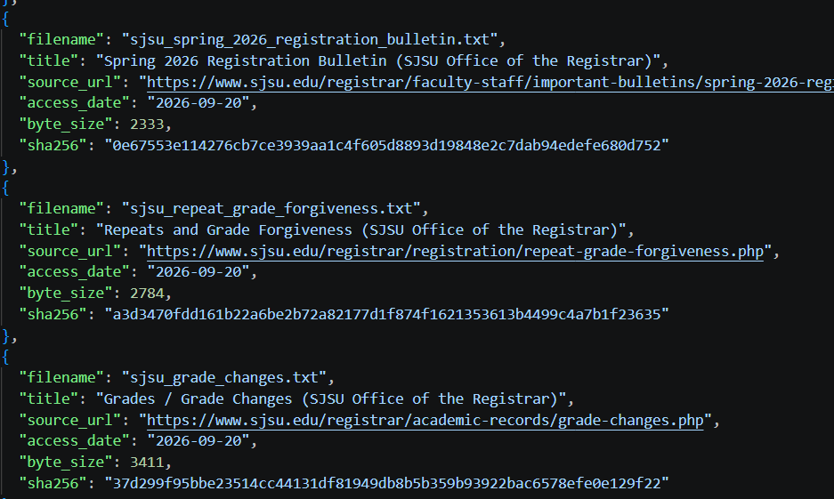
A few entries from CORPUS_MANIFEST.json.

The five questions
questions.yaml holds five domain questions, each with an expected answer and an expected source file, written and committed before any retrieval was run so the expected answers were not adjusted after seeing output. Three of the five depend on a fact that really only shows up in one specific document (a CS 46A recommendation, a CS 297 prerequisite, and the MSCS degree time limit), the other two are policy facts that show up worded similarly across more than one page.

Chunking code
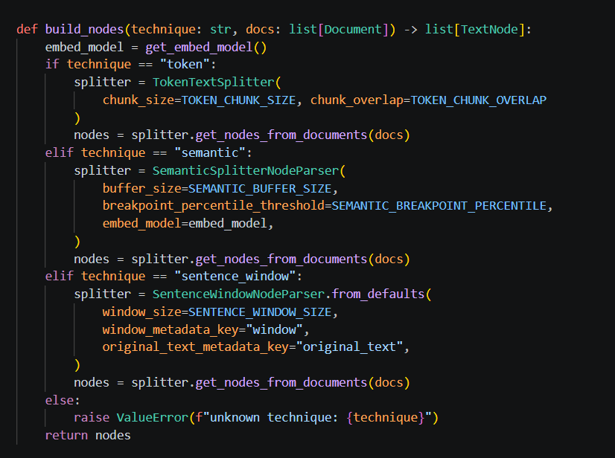
build_nodes(): all three technique branches.

Retrieval-only function
Given a query and k, this embeds the query, retrieves the top-k nodes, and for each one recomputes the cosine similarity by hand against a freshly computed document embedding rather than trusting whatever score the vector store cached, so the printed cosine number is independently checkable.
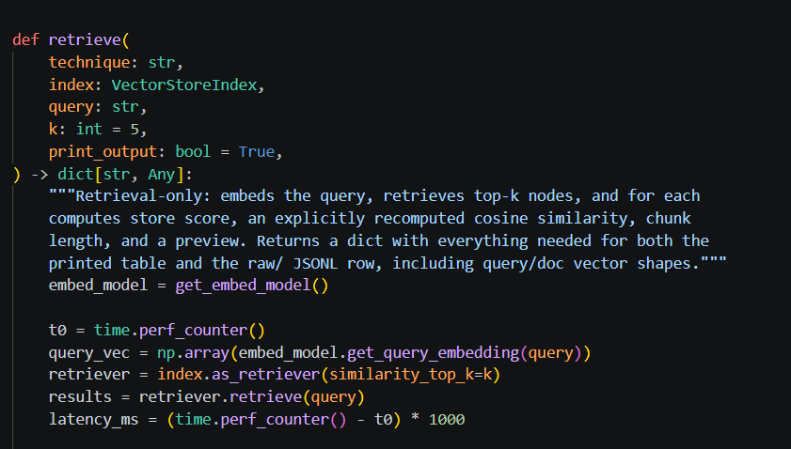
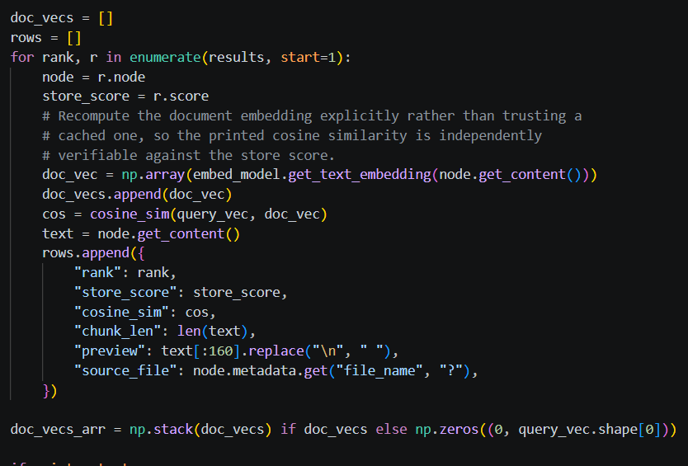

Running all three techniques against all five questions
Command used: python Part-5\run_retrieval_comparison.py
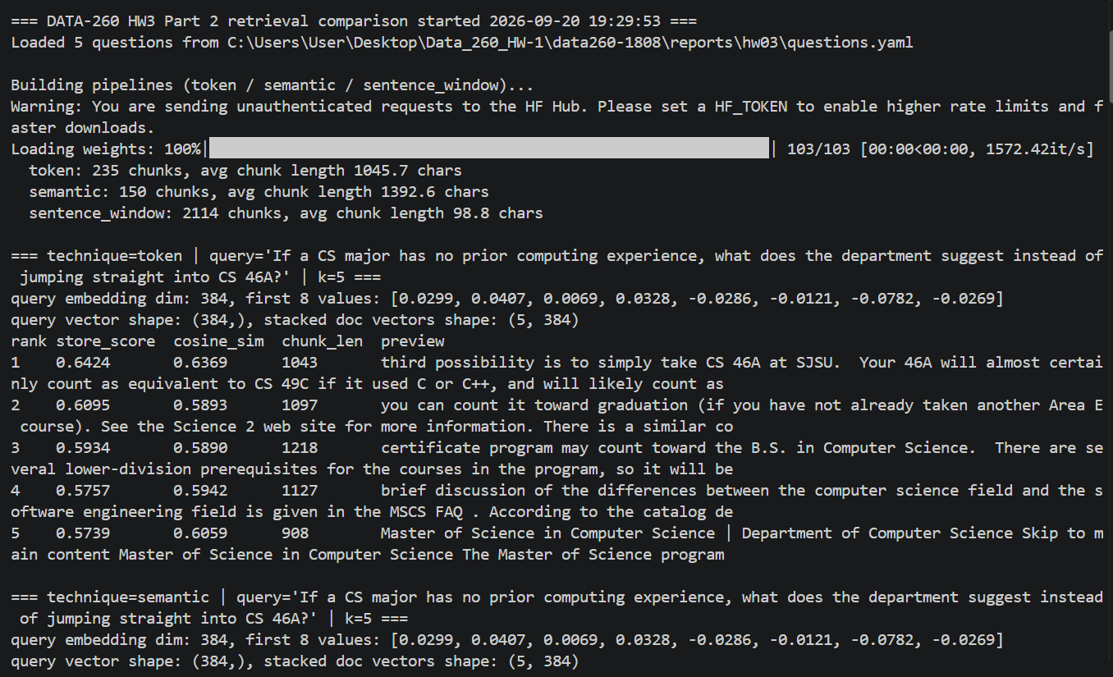
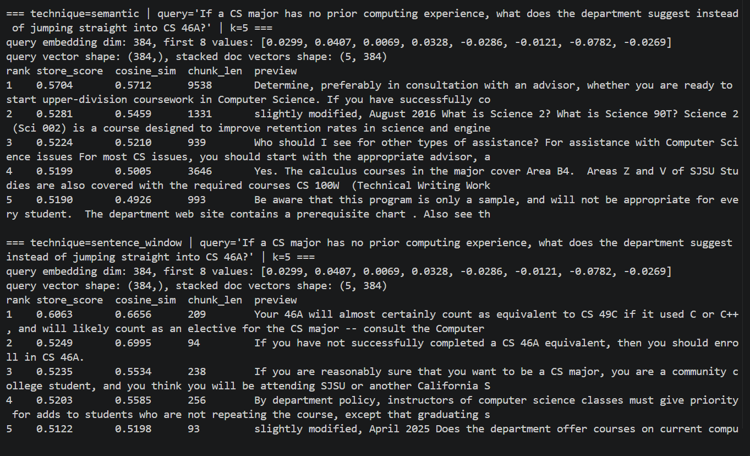
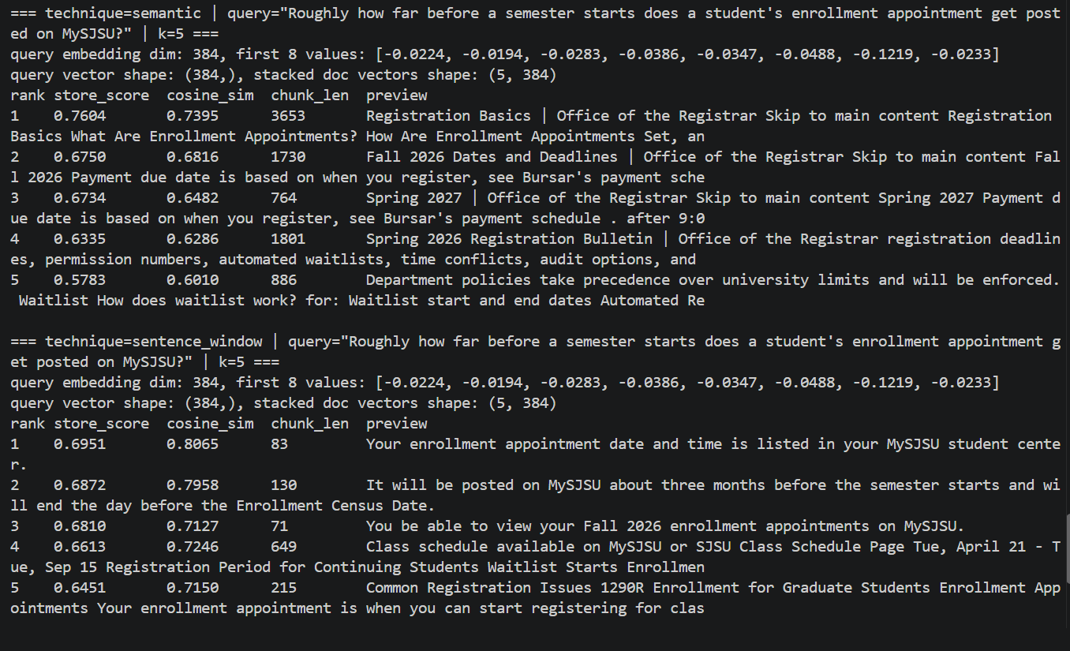
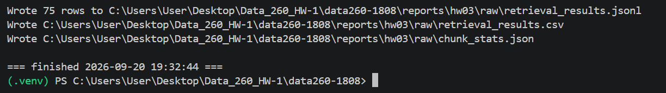
Chunk counts matched what the summary table below reports (token 235 chunks, semantic 150, sentence window 2114), plus the query embedding, top-k table (rank, store_score, cosine_sim, chunk_len, preview), and vector shapes for two of the five questions.
I do not have a screenshot of the compute_metrics.py run specifically (the script that recomputes the summary table below straight from the raw JSONL, no re-embedding). The numbers below are real, they come from that script's actual output, I just did not capture a screenshot of that particular terminal session before writing this up.

Results
Technique | Chunks | Avg chunk length | Top-1 cosine | Mean@k cosine | Recall@k | Mean latency (ms)
Token | 235 | 1045.7 | 0.6991 | 0.6329 | 1.00 | 77.77
Semantic | 150 | 1392.6 | 0.6560 | 0.6085 | 1.00 | 52.07
Sentence window | 2114 | 98.8 | 0.7239 | 0.6793 | 1.00 | 149.87
Recall@k here means: for each of the 5 questions, did at least one of the top-5 retrieved chunks actually come from that question's expected source file. All three techniques hit a perfect 1.00, with only 32 documents and fairly distinct topics the right document reliably shows up somewhere in the top 5 no matter how it got chunked, so recall does not separate these three here, cosine quality and latency do.

A confidently scored retrieval that does not contain the answer
For question 3 ("At what cumulative GPA is an undergraduate placed on academic notice?", expected source sjsu_socsci_academic_notice.txt), both token chunking (cosine 0.6931) and semantic chunking (cosine 0.7053) confidently returned a chunk from sjsu_grade_changes.txt instead, about grading symbols and how individual grades are calculated into GPA, not the 2.0 cumulative GPA cutoff for academic notice. My best guess why: both documents live in the same GPA and academic standing vocabulary neighborhood, so the embedding picks up on shared words like GPA, grade, and academic standing even though one document explains grade symbol mechanics and the other states a specific policy threshold. Same general subject, different specific fact.
A second miss, a different kind, showed up in sentence window chunking on question 5 (enrollment appointment timing), cosine 0.8065, the single highest confidence miss of the whole run, attributed to sjsu_chhs_faqs.txt instead of the expected sjsu_registration_basics.txt. The retrieved sentence ("Your enrollment appointment date and time is listed in your MySJSU student center") is actually true, it is just that the same boilerplate fact about enrollment appointments is repeated across more than one SJSU college FAQ page, since registration procedures are university wide. So this is less a bad retrieval and more that treating one file as the single canonical source understates how well the retrieval actually did when the same fact legitimately lives in more than one document.

Observations
Sentence window chunking had the best cosine scores by a real margin (0.72 top-1 versus 0.70 for token and 0.66 for semantic). That tracks: each indexed unit is one sentence, so when the query and the answer share a specific sentence's vocabulary, nothing else in that chunk waters it down. The cost shows up directly in latency, sentence window is roughly 2 to 3 times slower than the other two, since it is searching over 2114 vectors instead of 150 to 235. Semantic chunking produced the fewest, longest chunks and was the fastest, but also had the lowest cosine scores, grouping several sentences into one chunk means the embedding represents more mixed content at once, which blurs how sharply it matches a narrow question.
The best technique differed a little by question. For the two very specific, narrow FAQ facts (questions 1 and 2), sentence window's top-1 cosine was clearly ahead, since the exact answering sentence could be its own chunk. For the questions where the useful chunk is more like a short paragraph than one sentence, token and semantic still did fine, but sentence window sometimes split the answer awkwardly across two adjacent one-sentence chunks instead of one clean hit.

Conclusion
For this corpus I would pick sentence window chunking. Its cosine scores were consistently the highest and its recall tied the other two at a perfect 1.0, so it finds the right document just as reliably and scores its best match more confidently. The latency cost, about 150ms mean versus 52 to 78ms for the others, is real but still well under a fifth of a second per query at this corpus size, not a meaningful cost for a retrieval-only step. If the corpus were much bigger, the full SJSU catalog instead of 32 pages, that latency gap would start to matter more and I would lean back toward token chunking instead, good enough cosine scores, far fewer chunks to search over, and simpler to reason about than semantic breakpoint detection.

AI_USE

1. What I used an AI assistant for, and what I did myself
I used Claude Code to write essentially all the code for both parts: the FastAPI auth router and Bootstrap templates, the corpus fetch and clean script, and the three technique LlamaIndex chunking and retrieval pipeline plus the metrics recompute script. It also ran everything on this machine, starting the auth server and testing login, session, and idle timeout behavior with curl, fetching the real SJSU pages, and running the actual embedding model locally to produce the retrieval comparison numbers.
What I did myself: picked which SJSU pages to use as the domain corpus (and rejected using catalog.sjsu.edu once it turned out to be gated), wrote and verified the five questions.yaml questions and their expected answers by hand against the actual corpus text before any retrieval was run, and made the final call on chunking parameters and on which technique to recommend in the conclusion.

2. One AI-produced output that was wrong or unsuitable
The first version of the corpus cleaning script only stripped literal nav, header, and footer tags. On ischool.sjsu.edu pages that left a wall of one and two word menu lines (a persistent sidebar rendered as a plain div and ul, not a semantic nav element) ahead of any real content, and the saved clean text files ended up almost entirely nav noise with the actual article content buried in the middle, one file had roughly 200 lines of menu items before its two real paragraphs. Total corpus size after this first pass was only 27.9KB, well under the 200KB minimum, even though the raw HTML fetched totaled almost 1MB.

3. How I detected the problem
By actually reading one of the saved output files line by line instead of just trusting the byte count. The first 60 lines were obviously a site navigation menu, single words and short phrases like Financial Aid and Scholarships and Internships, which made it clear the issue was not that the pages lacked content, it was that the cleaning was not distinguishing real content from menu chrome that happened to sit outside a nav tag.

4. What I changed and why it works now
Added a second cleaning pass: strip elements whose id or class matches common sidebar, menu, or breadcrumb naming patterns, then collapse any run of 4 or more consecutive short lines that do not end in sentence punctuation, on the idea that real prose almost always ends in a period, question mark, or colon while menu items almost never do. Re-running the fetch after this change dropped the near empty ischool.sjsu.edu pages down further, confirming those pages really were almost all chrome, while www.sjsu.edu FAQ style pages kept most of their real paragraph content. After adding more of those pages the corpus reached 208.4KB, clearing the requirement with real, readable text, which I verified by re-reading a sample of the output files again and confirming they now read as actual paragraphs rather than menu dumps.
A second, smaller thing worth recording: in the retrieval output, the vector store's own store_score and the cosine similarity I recomputed by hand from the raw embeddings do not always match exactly (one row showed store_score 0.5835 versus recomputed cosine_sim 0.6305 for the same chunk). I did not chase down the exact reason, it could be a normalization difference inside the store, but I kept both numbers in the output and the report rather than assuming they meant the same thing, since the assignment asks for both to be printed separately.

